21.33: Let 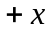 be to the right and 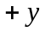 be downward.
Use the horizontal motion to find the time when the electron emerges from the field:
